**Practical Assignment: 6**

**Aim:** Extract your City data like Road, building, lake and other features from Open Street Map in QGIS

**Theory**: Here is a more detailed theory on extracting city data like roads, buildings, lakes, and other features from OpenStreetMap (OSM) in QGIS:

**Spatial Data Structures**

Vector Data: OSM data is stored as vector data, consisting of nodes, ways, and relations.

Raster Data: QGIS can also handle raster data, such as satellite imagery or elevation models.

**OSM Data Model**

Nodes: Represent points on the map, such as building locations or road intersections.

Ways: Represent linear features, such as roads, rivers, or building outlines.

Relations: Represent relationships between nodes and ways, such as a building's address or a road's name.

**QGIS Spatial Analysis**

Vector Analysis: QGIS provides various vector analysis tools, such as intersection, union, and difference.

Spatial Join: Joins two vector layers based on spatial relationships, such as intersection or proximity.

Buffer Analysis: Creates a buffer zone around a feature, useful for proximity analysis.

**OSM Data Extraction**

Tag-Based Extraction: Extracts features based on specific OSM tags, such as highway, building, or waterway.

Spatial Querying: Extracts features based on spatial relationships, such as intersection or proximity.

**Results:**

**Step 1: open QGIS**

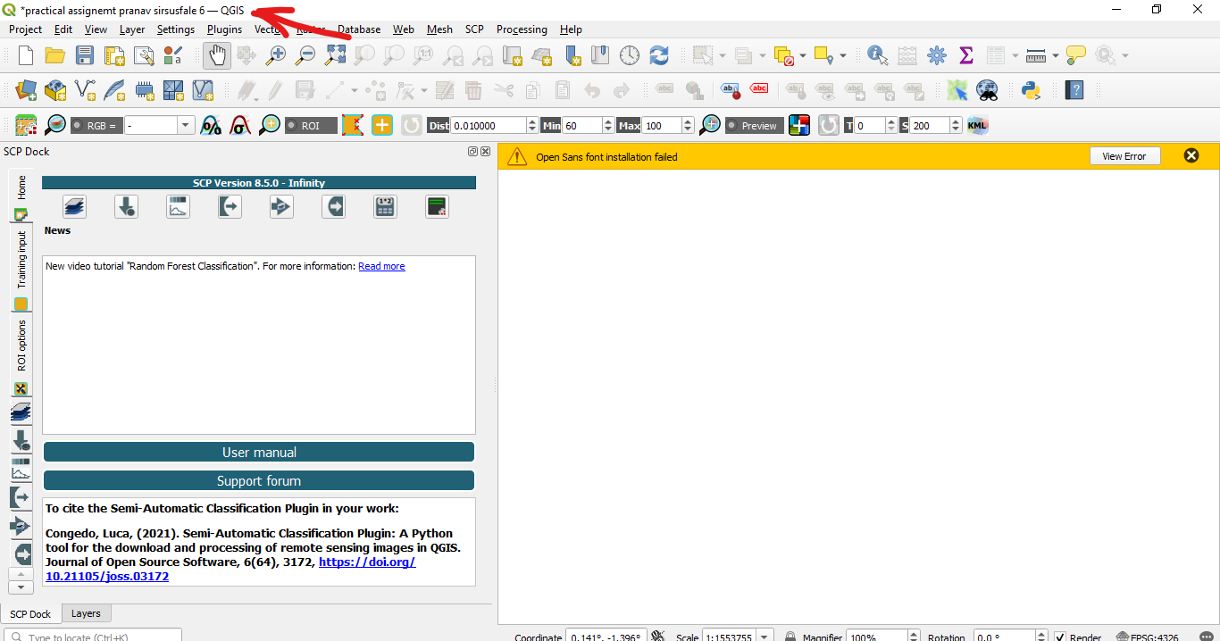

**Step 2: install quickOSM pulgging**

|  |  |
| --- | --- |
|  |  |

Step 3: openi QuickOSM and set key as highway and value as primary secondary and tertiary and its result

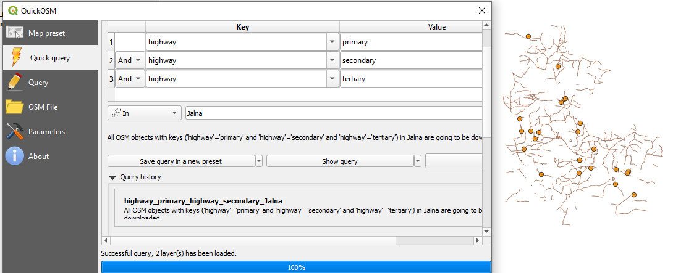

Step 4 : add buildings and it’s results.

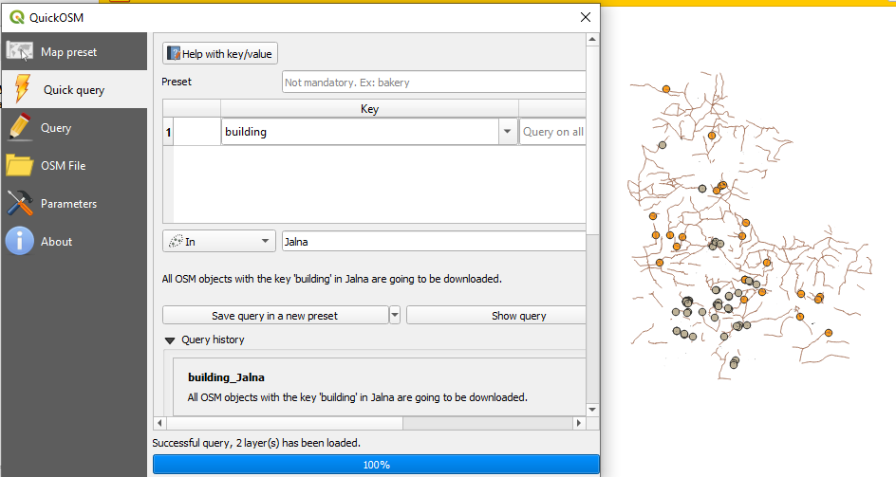

Step 5: add waterway and its result.add boundry

|  |  |
| --- | --- |
|  |  |

|  |  |
| --- | --- |
| Step 6. All layers | Step 7. Final Result |